Table of contents:

1. Create Users microservice
2. Create Eureka discovery service
3. Add the users microservice to Eureka Discovery Service as a client
4. Add the API Gateway
5. Configure routes, filters, rewrite url in API gateway
6. Run user service multiple times with customized port number and name.

Sample microservice architecture.

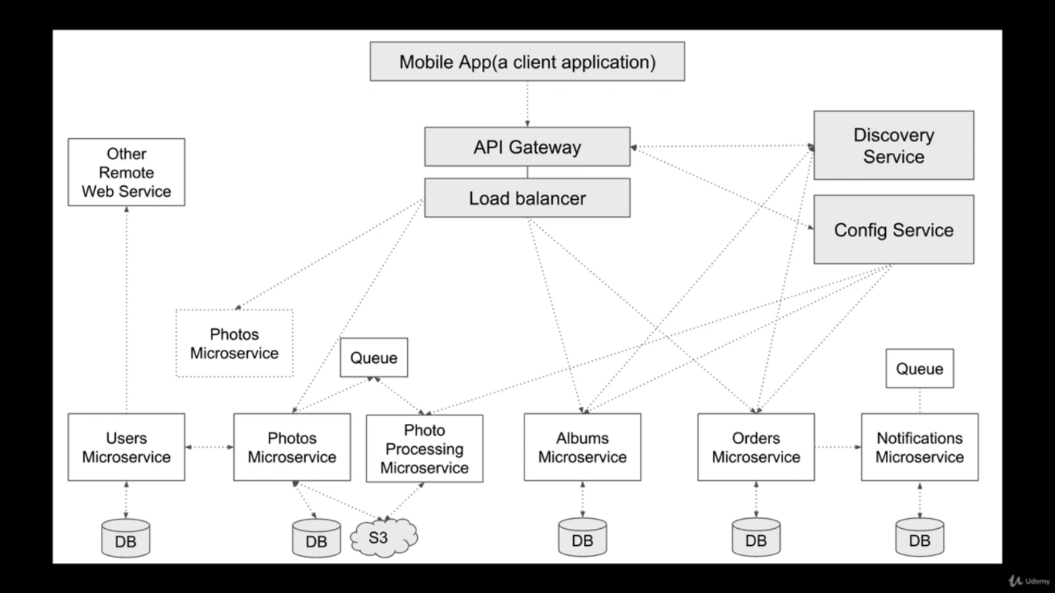

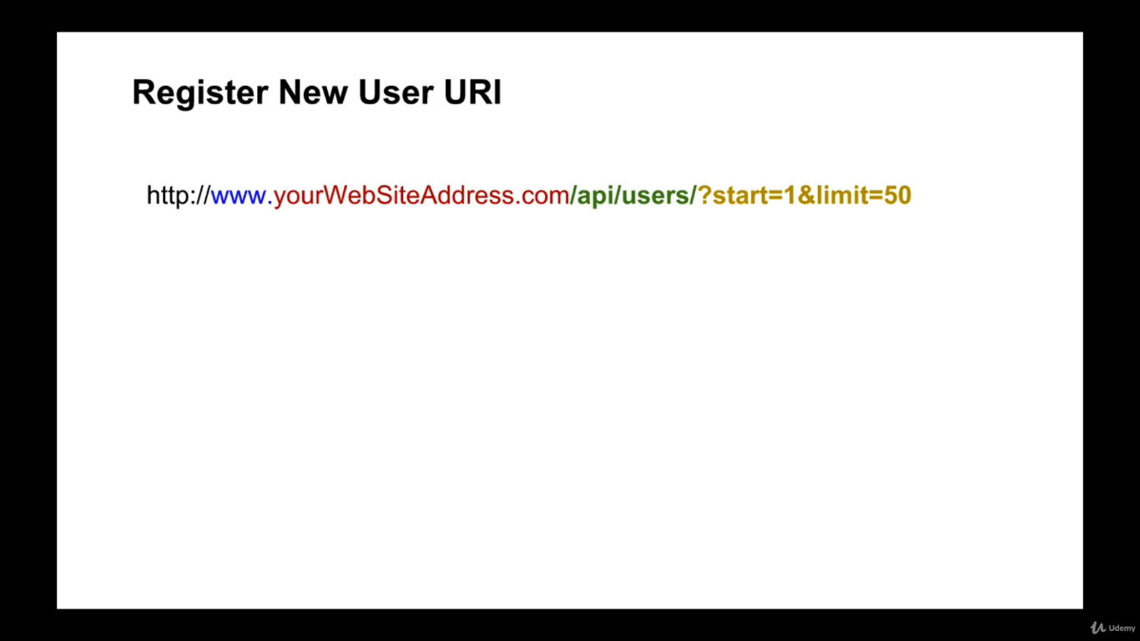

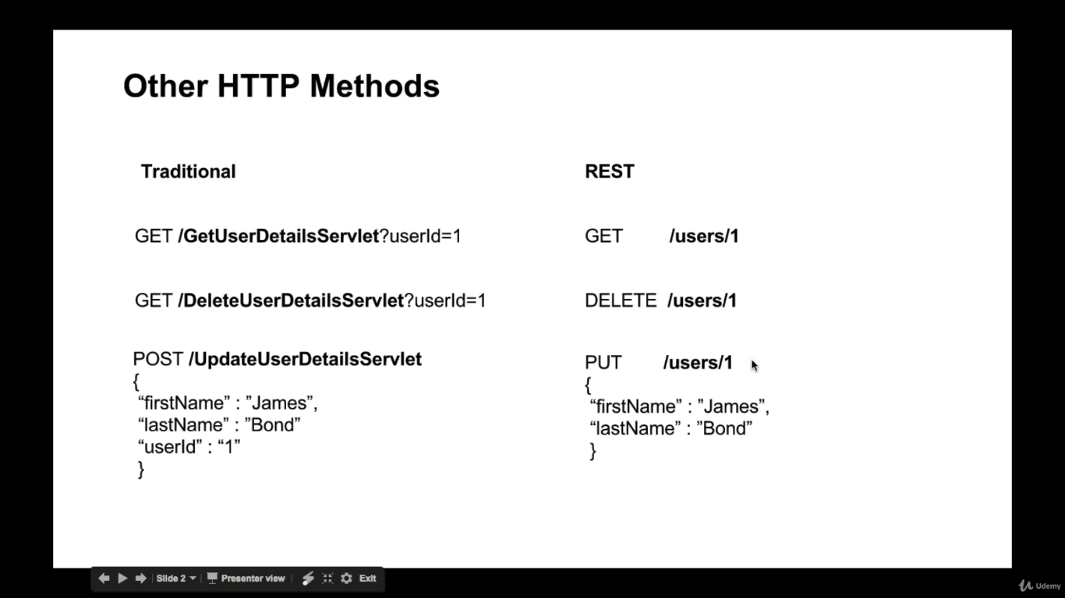

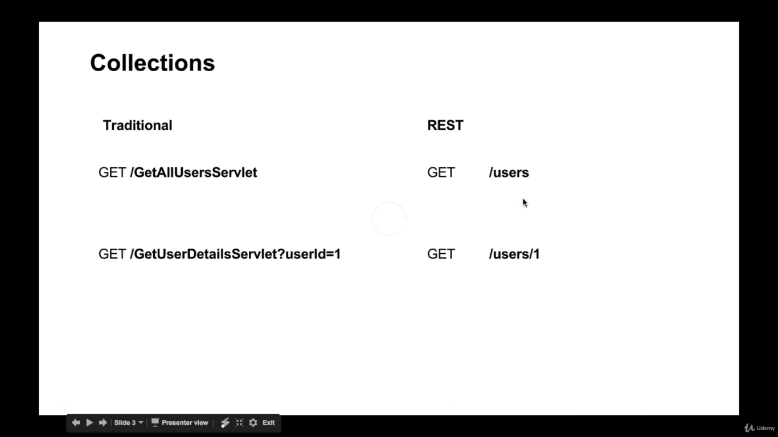

**RESTFull WebServices:**

Reading path variable with @pathVariable annotation

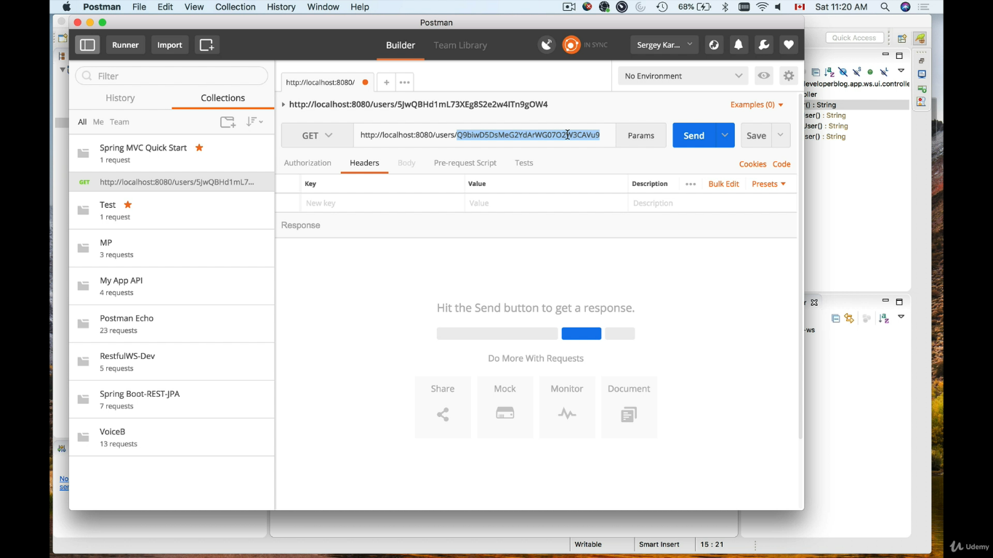

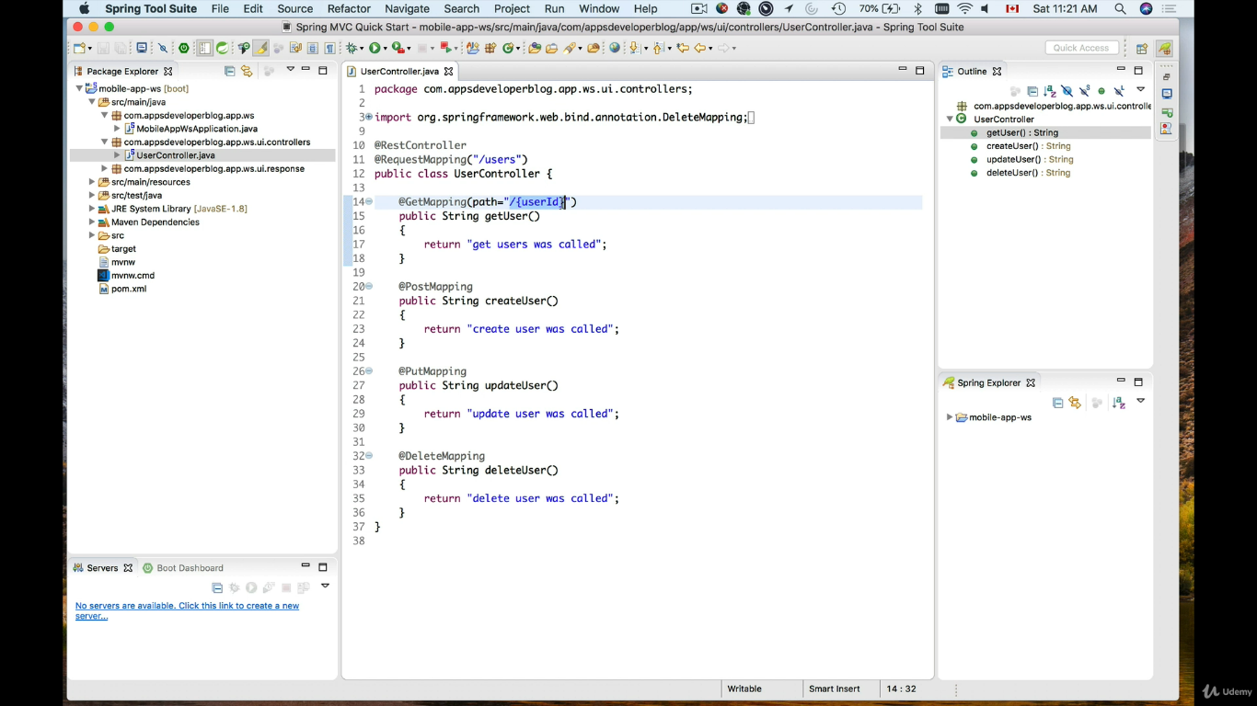

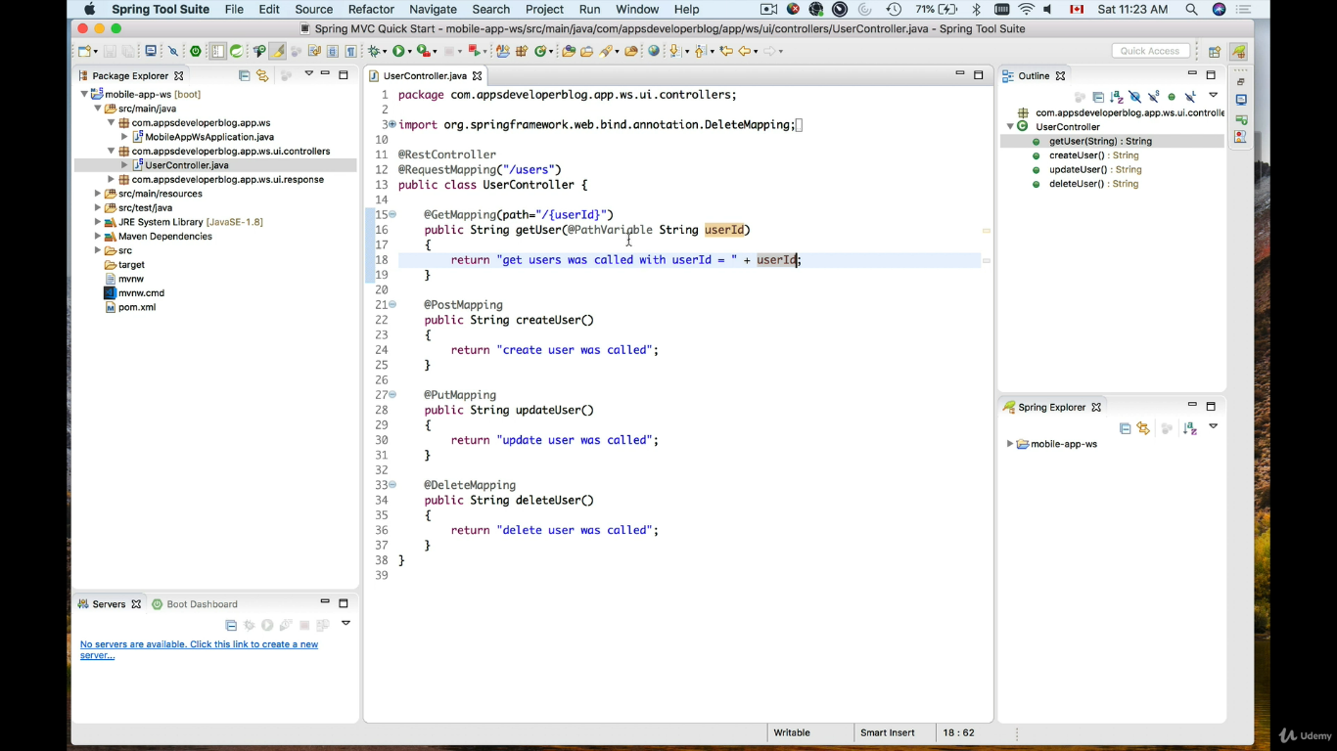

Reading query string request parameter

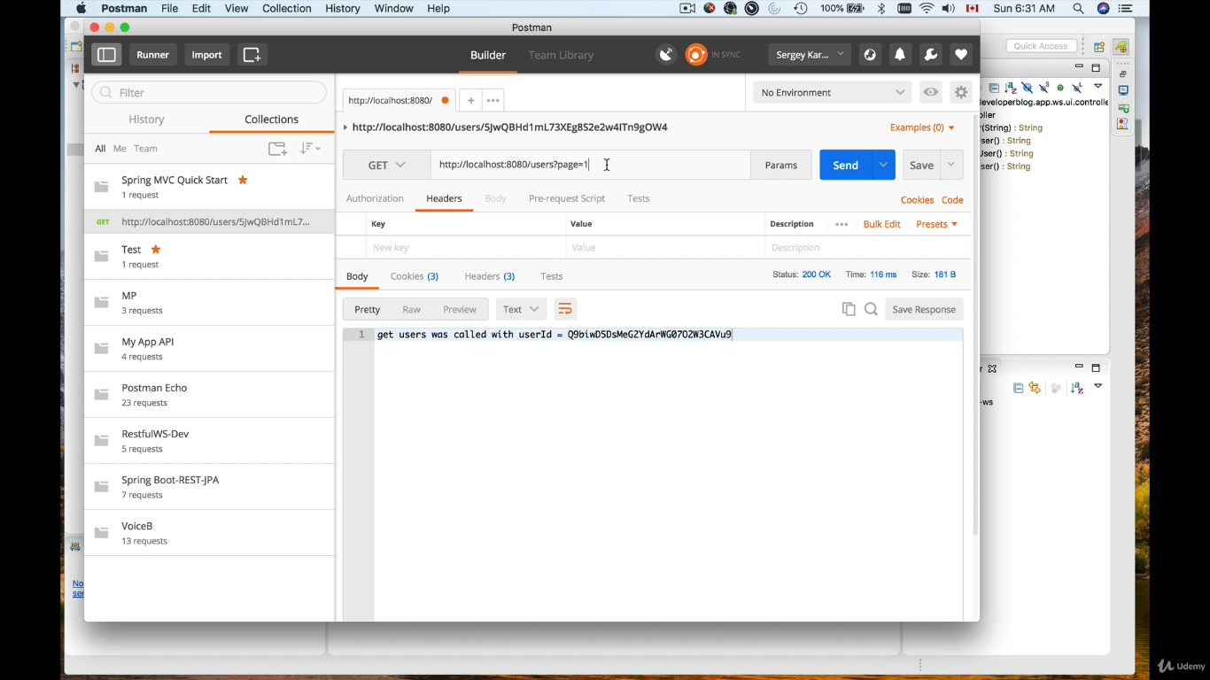

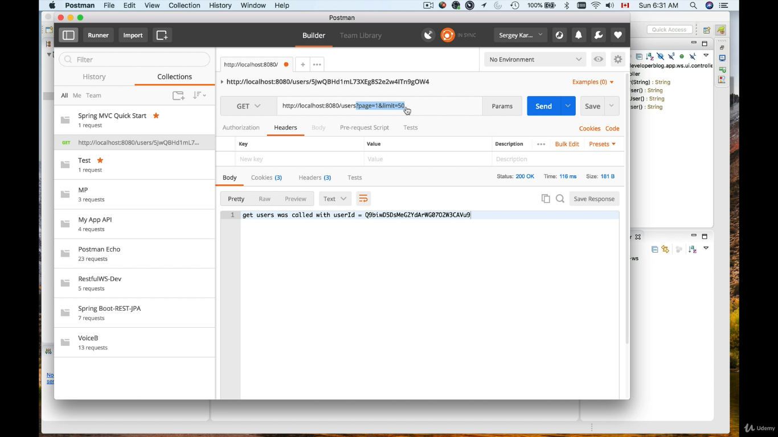

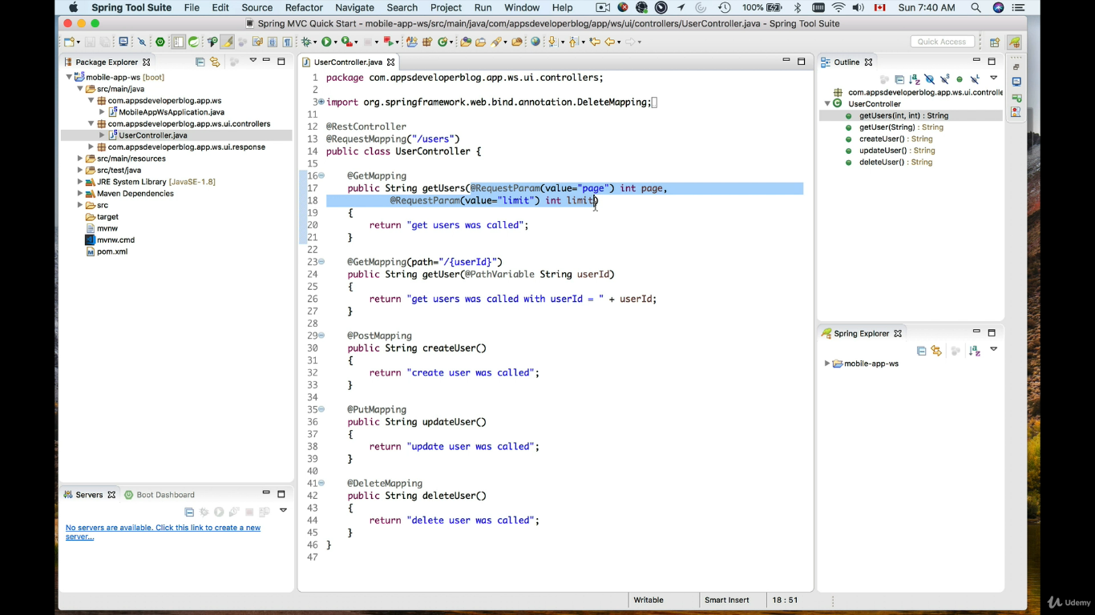

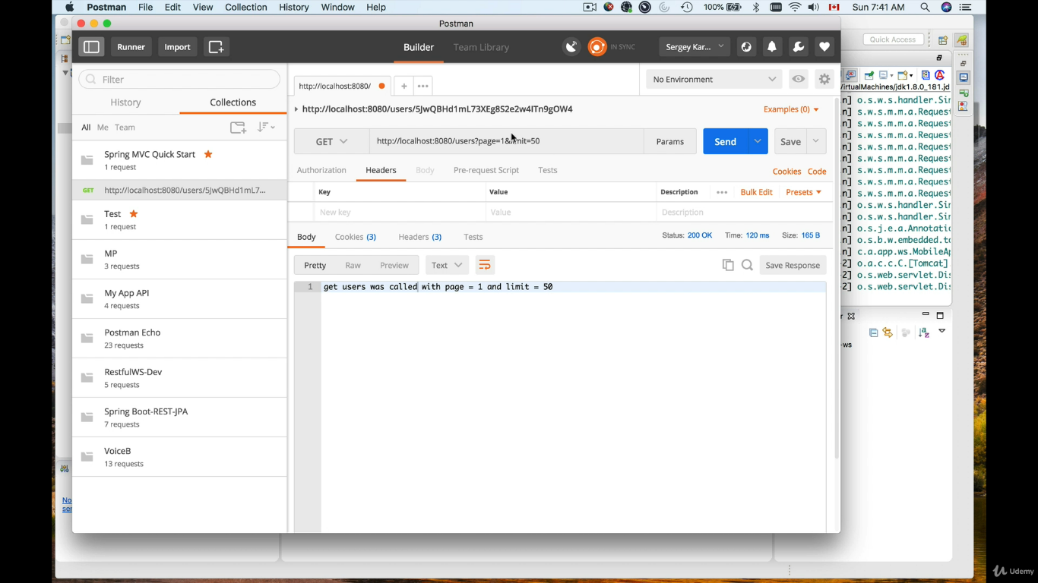

But when we send only one parameter then we get error.

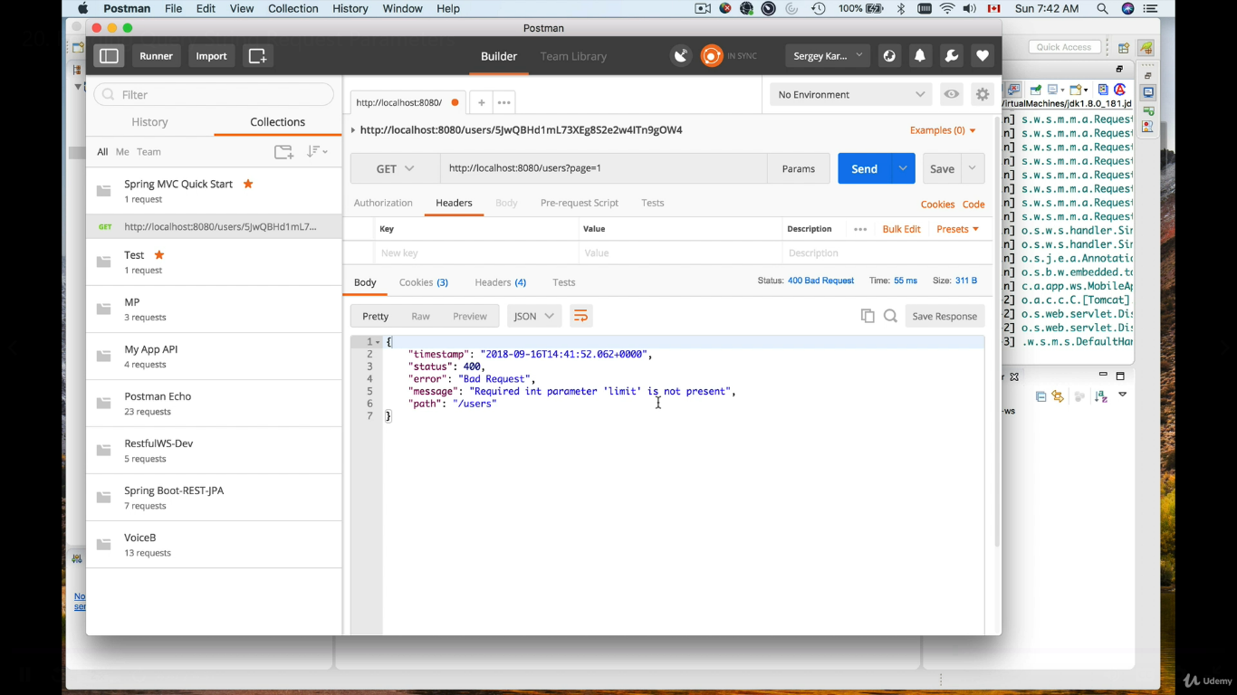

So we have to make request parameter optional and required.

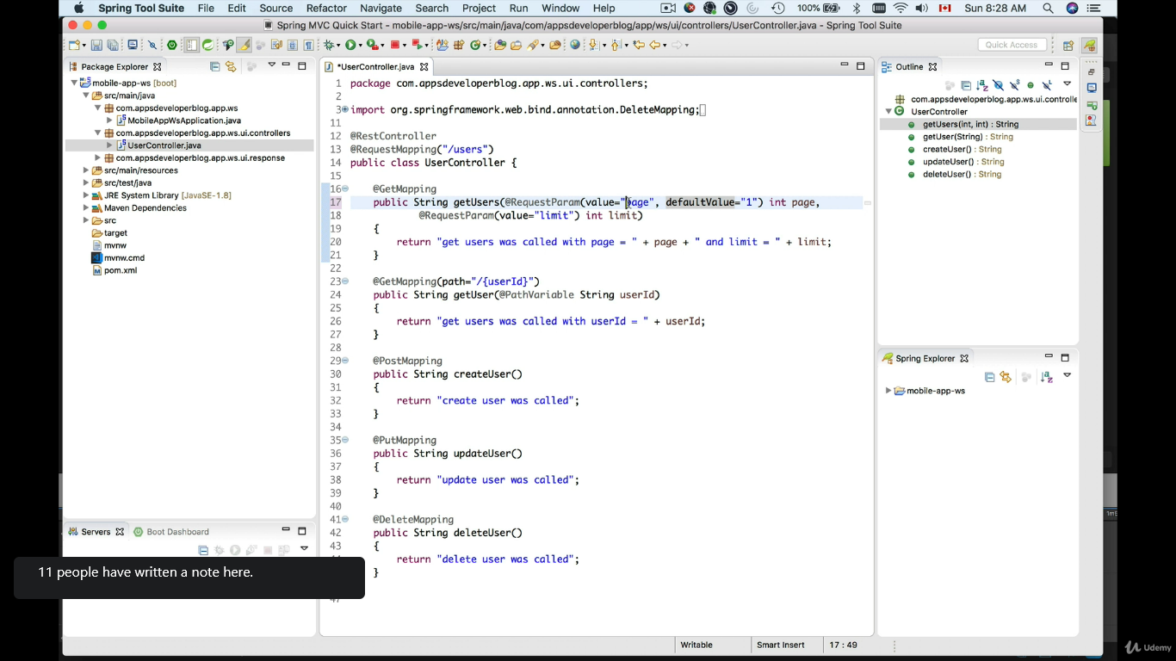

Since we have set the default value above we are getting the response even without sending the parameter.

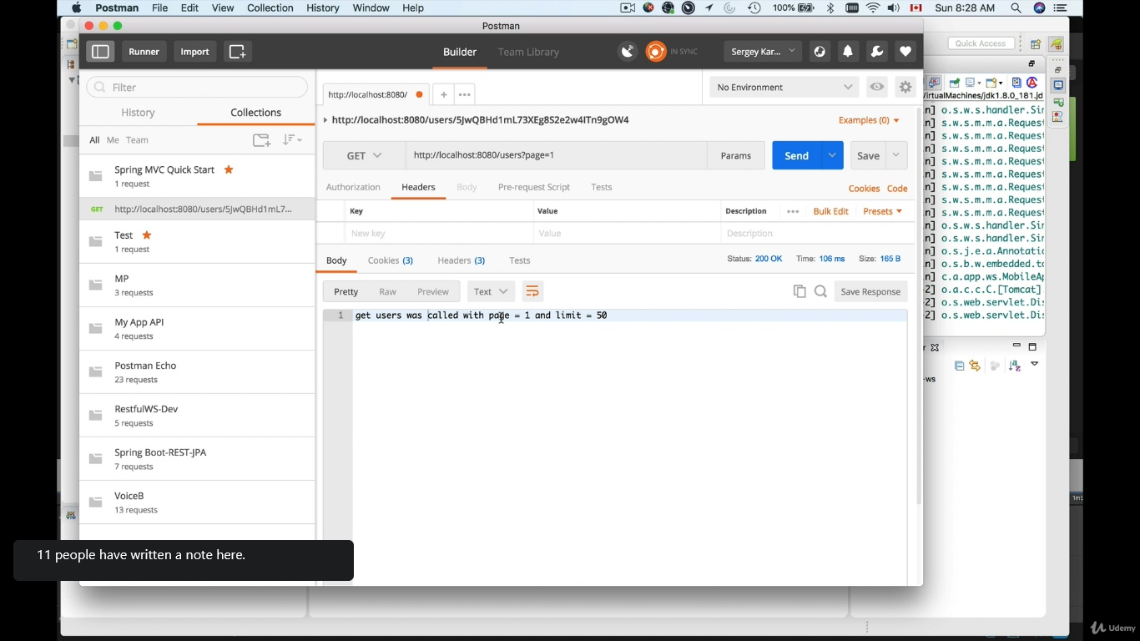

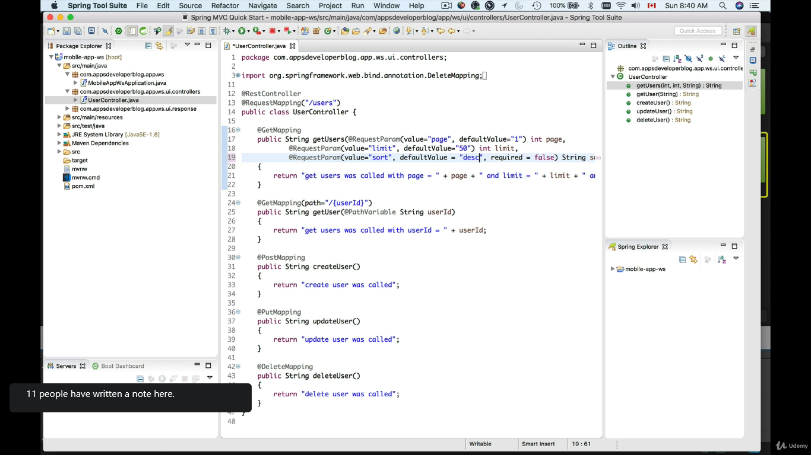

Returning object as Json and Xml representation

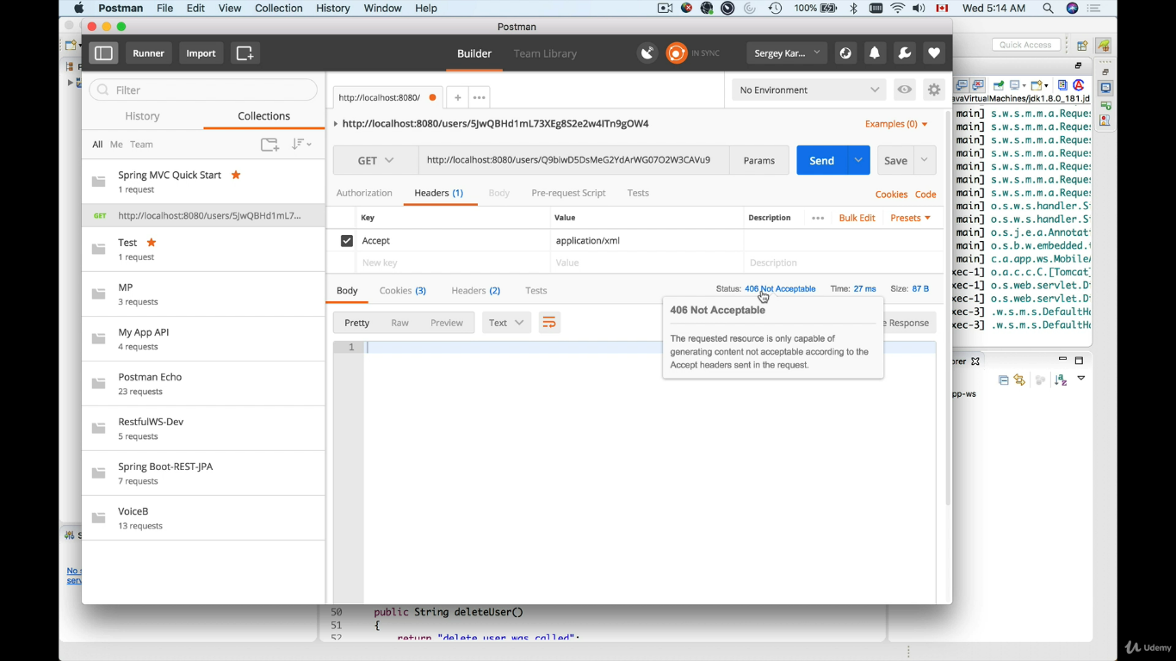

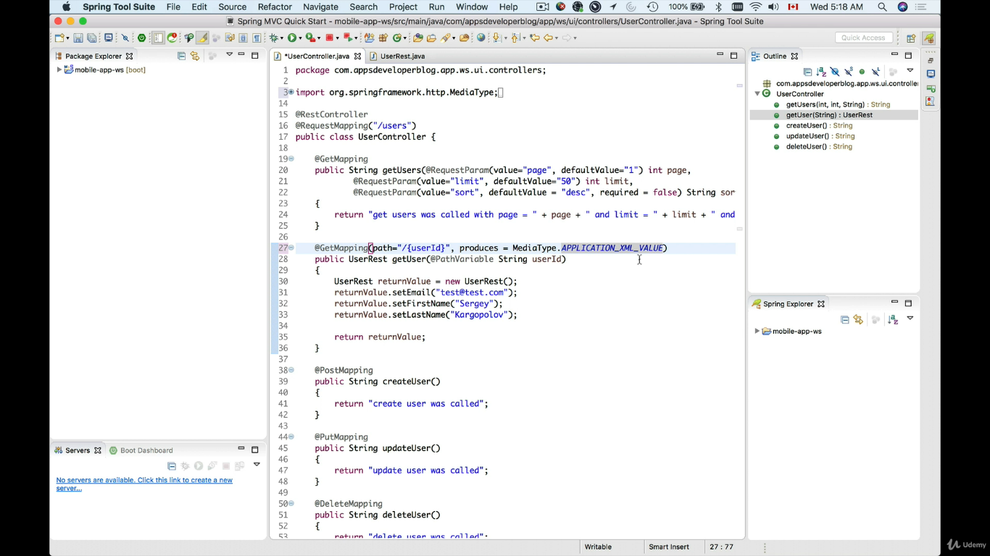

Look at the media type

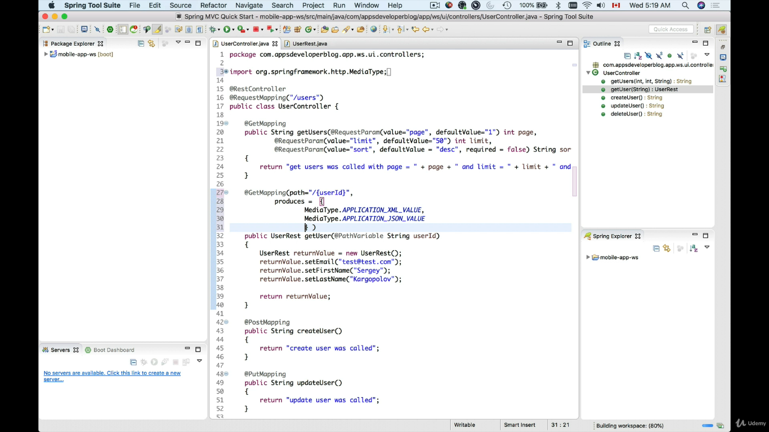

If you get error then insert this dependency Jackson data format.

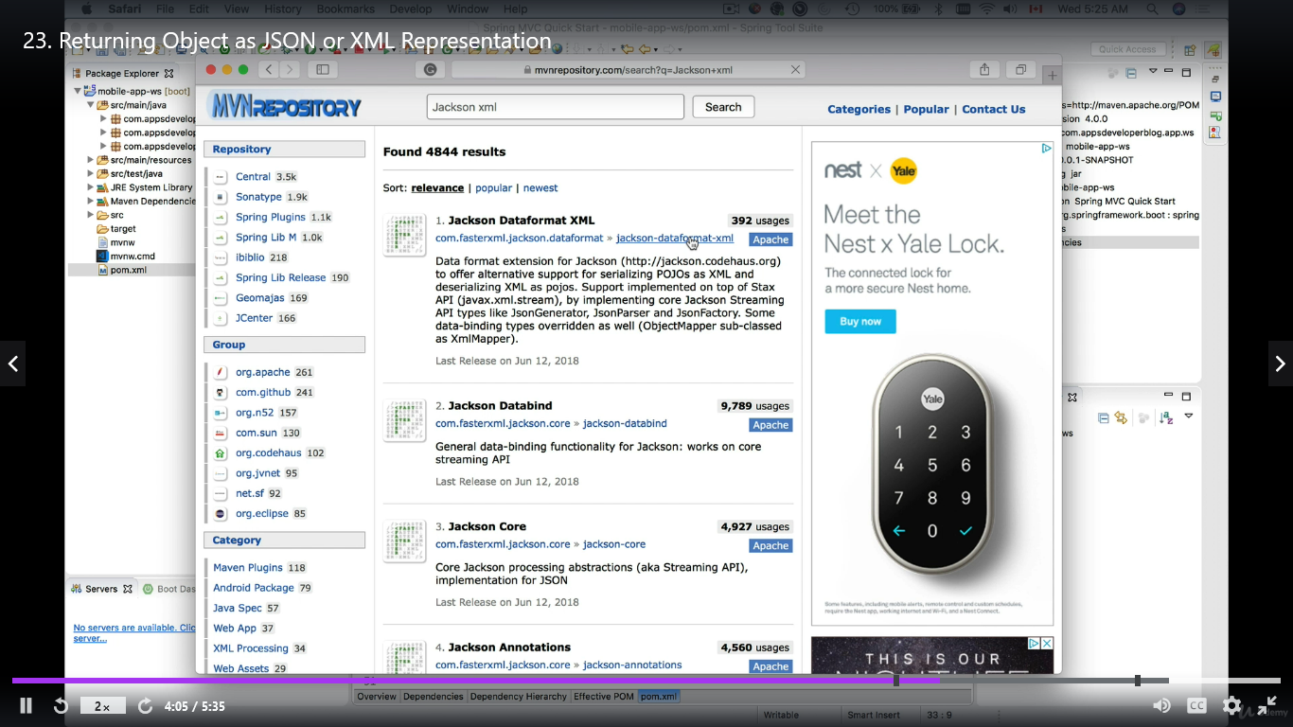

**Set response status code.**

User response entity

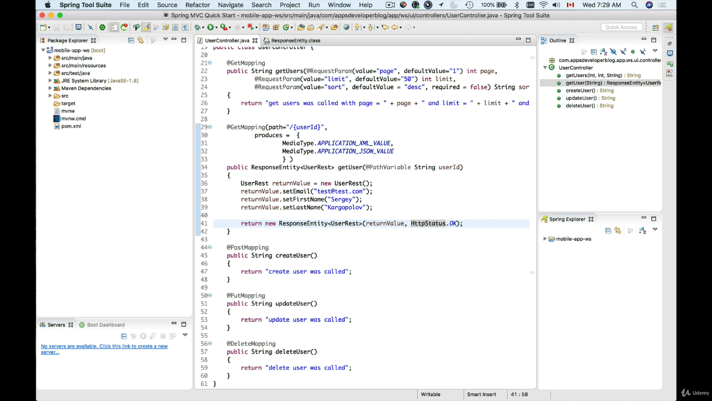

Exception Hanlder

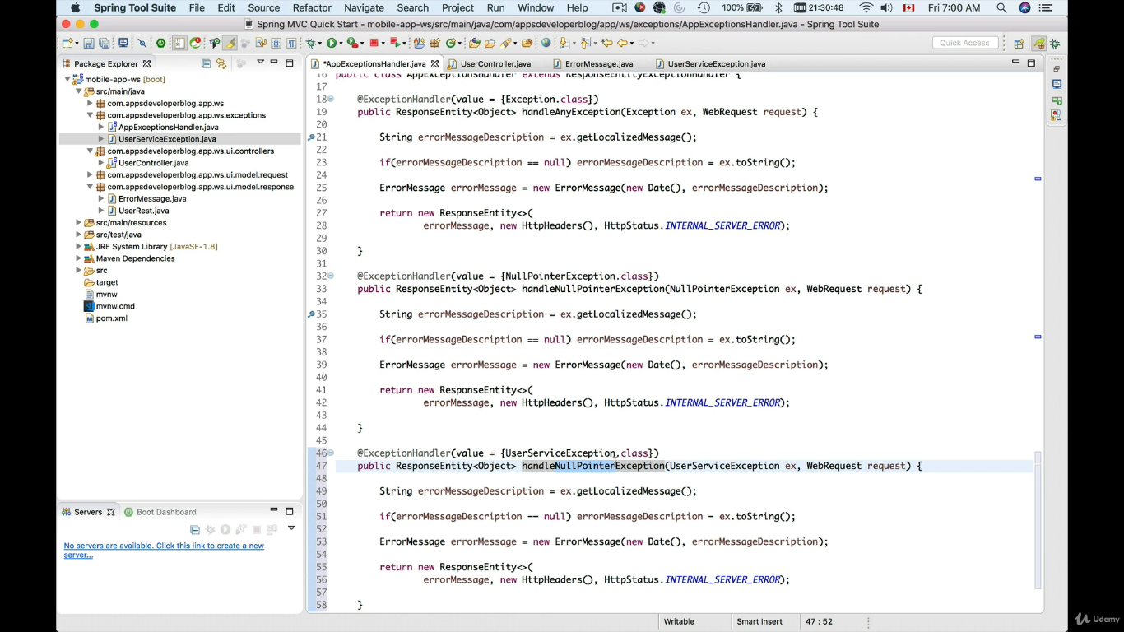

Catch more than one exception in one method.

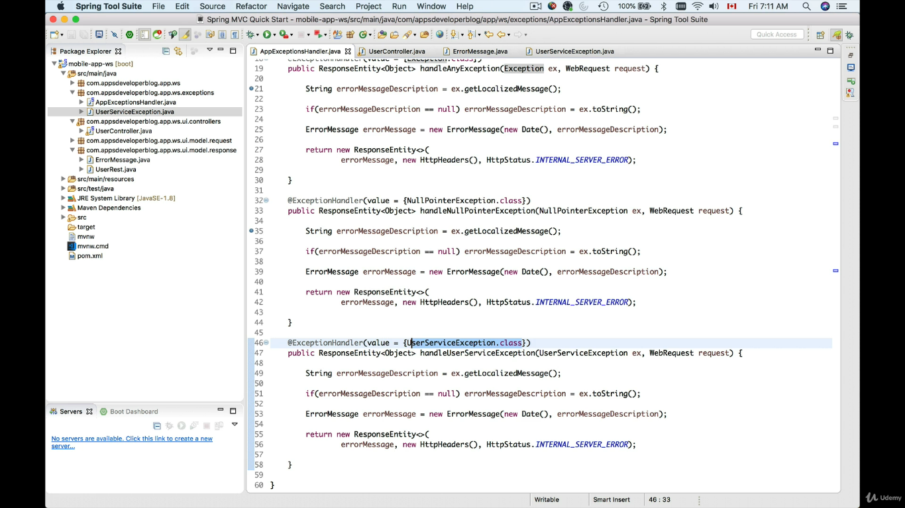

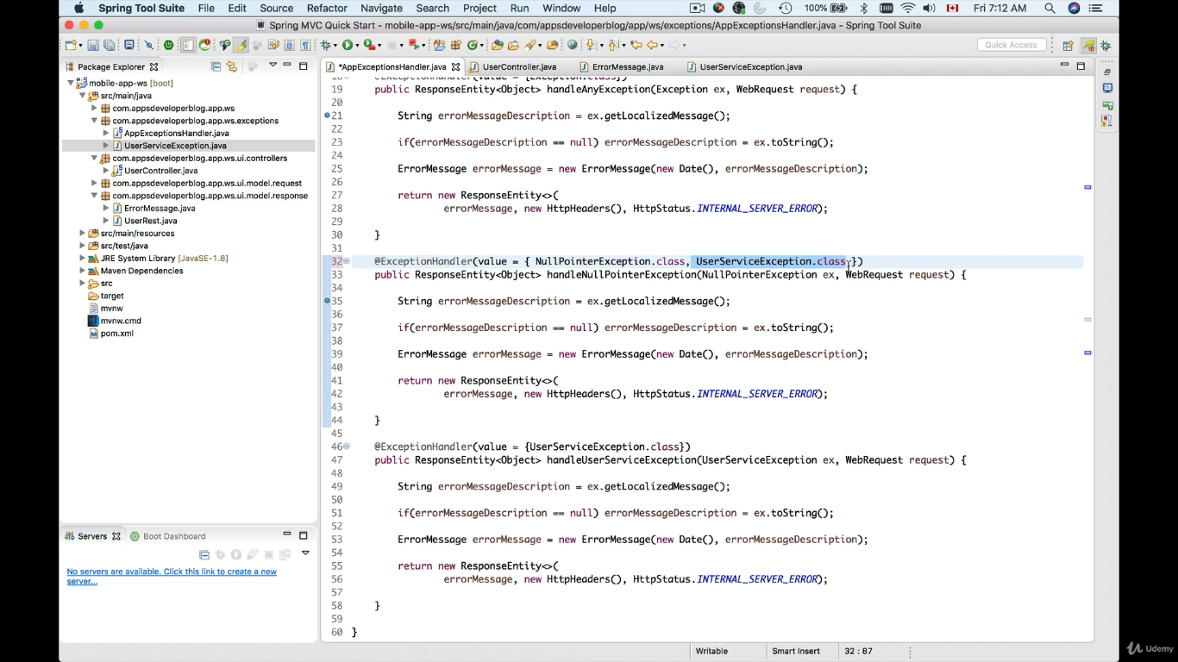

Catch the exception instead of null pointer exception

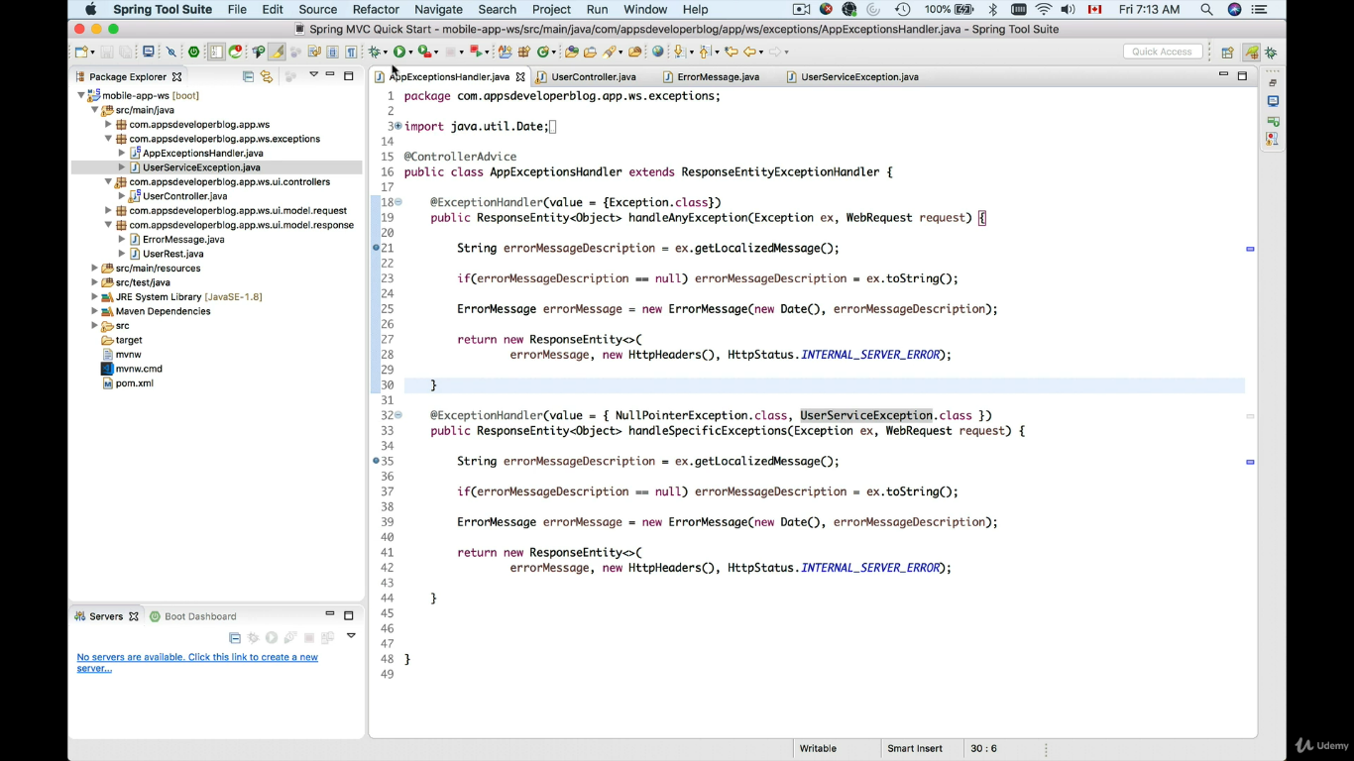

**Edureka Discovery Service**

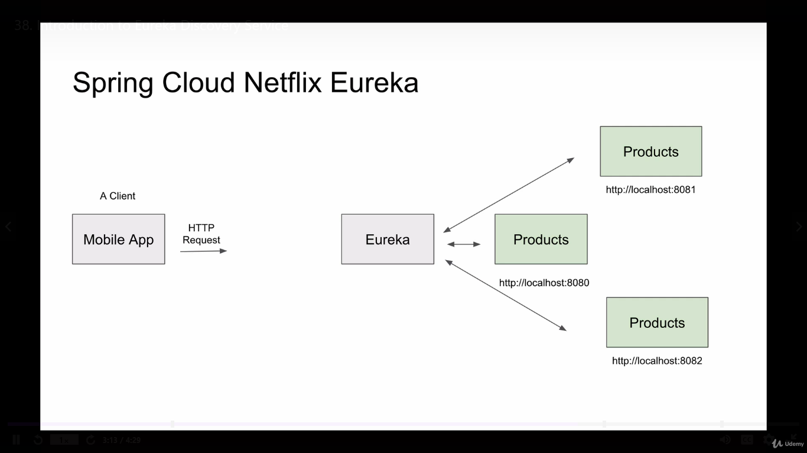

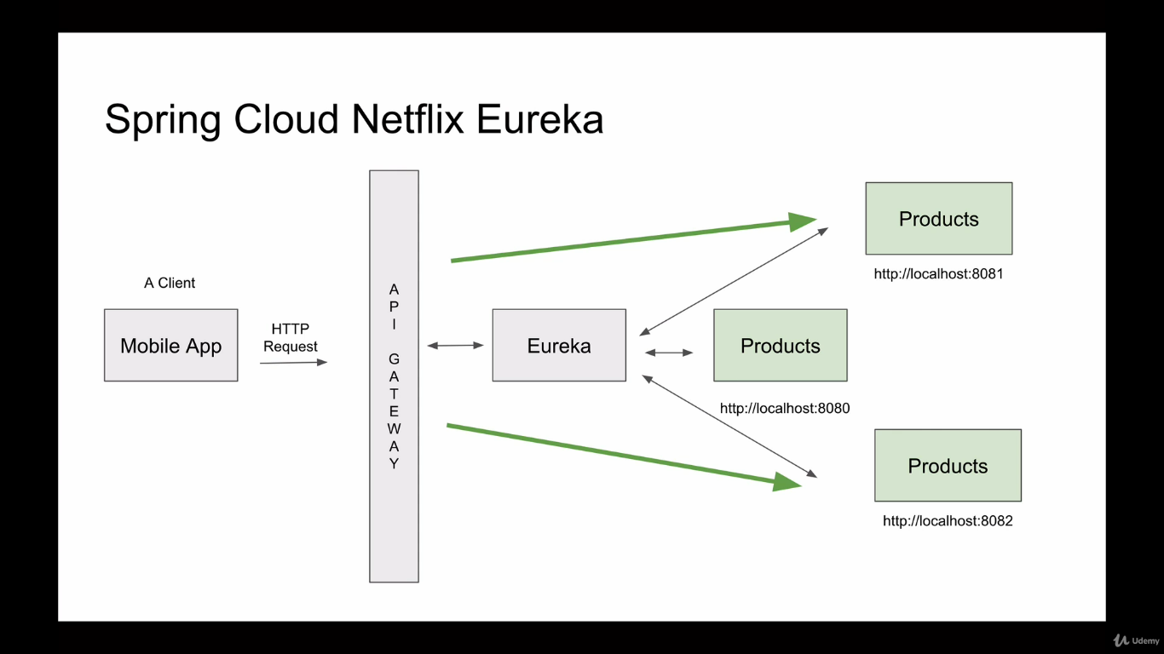

Add the following dependencies, Eureka client and Eureka Server

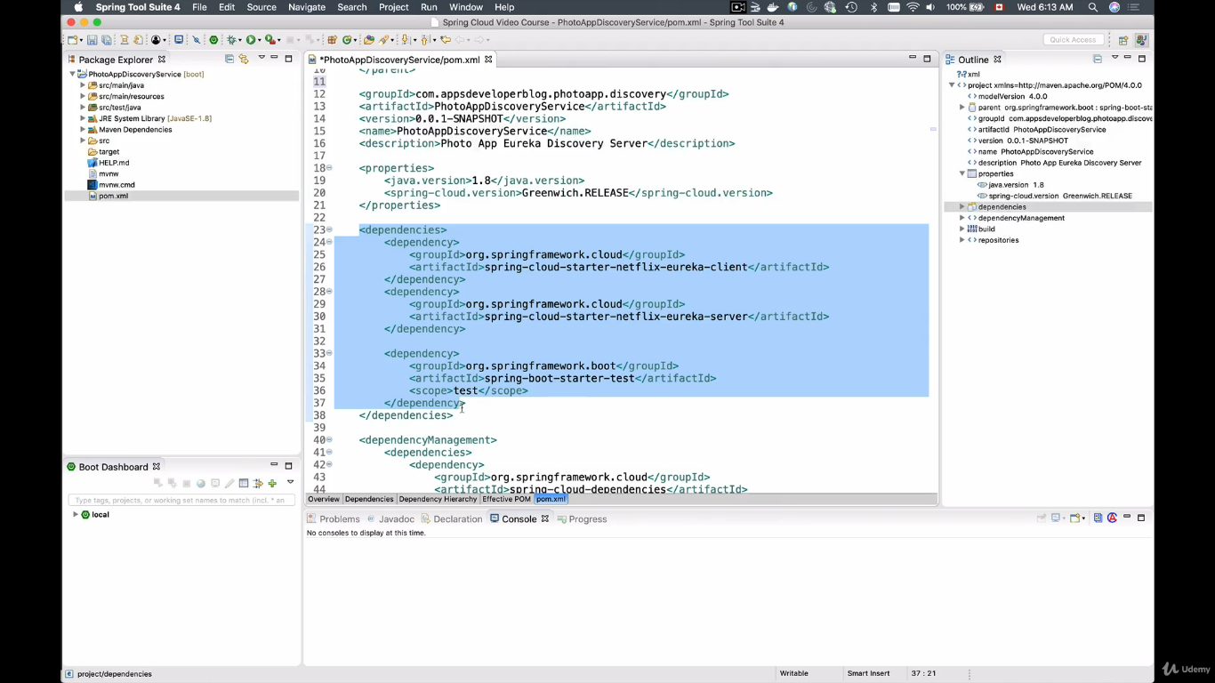

Add annotation @enableEurekaServer

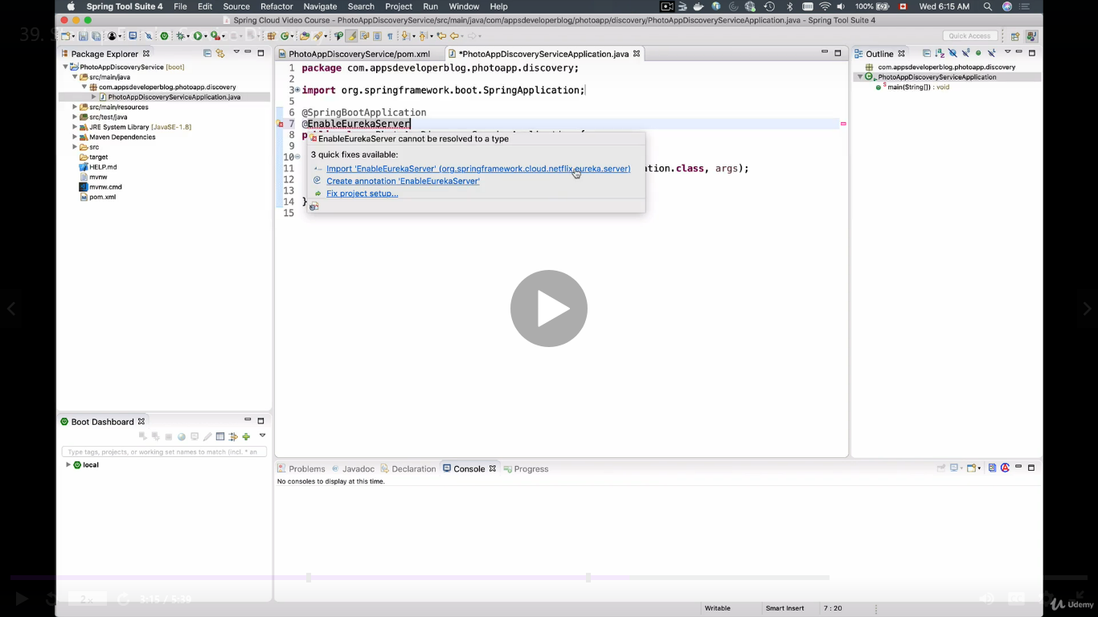

And paste the application properties

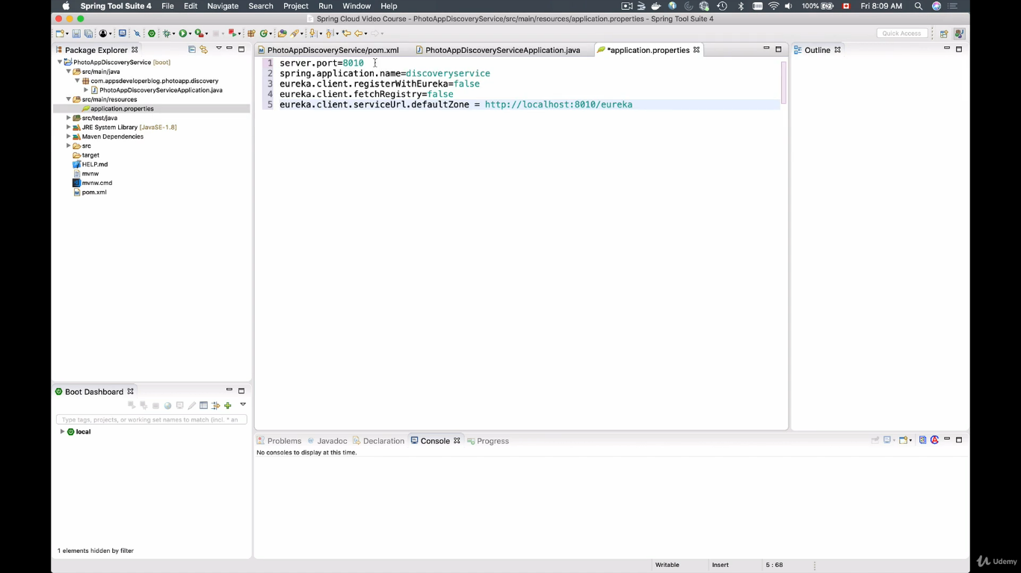

In order to avoid this application to register in eureka as a client we set the following properties

eureka.client.reisterWithEureka =false

eureka.client.fetchRegistry = false

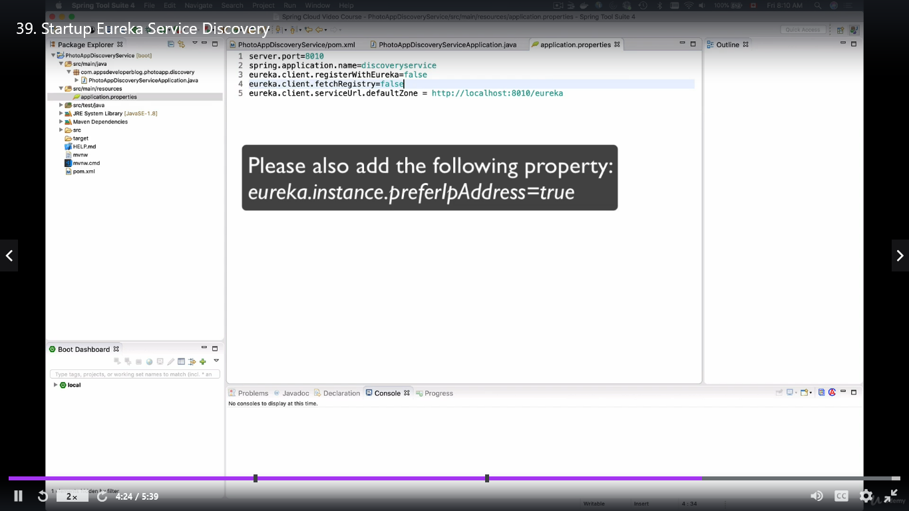

eureka.client.serviceUrl.defaultZone = <http://localhost:8010/eureka>

This is the property value using which the client will communicate to eureka server.

Run the application and navigate to URL to display the eureka dashboard.

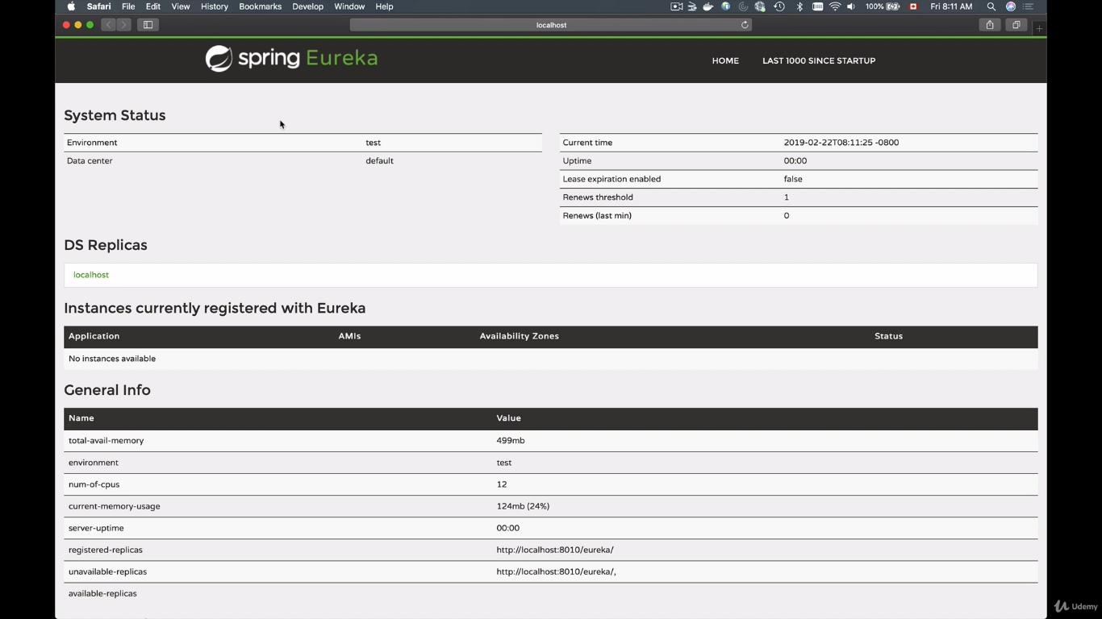

Creating a user microservice as a client to eureka server

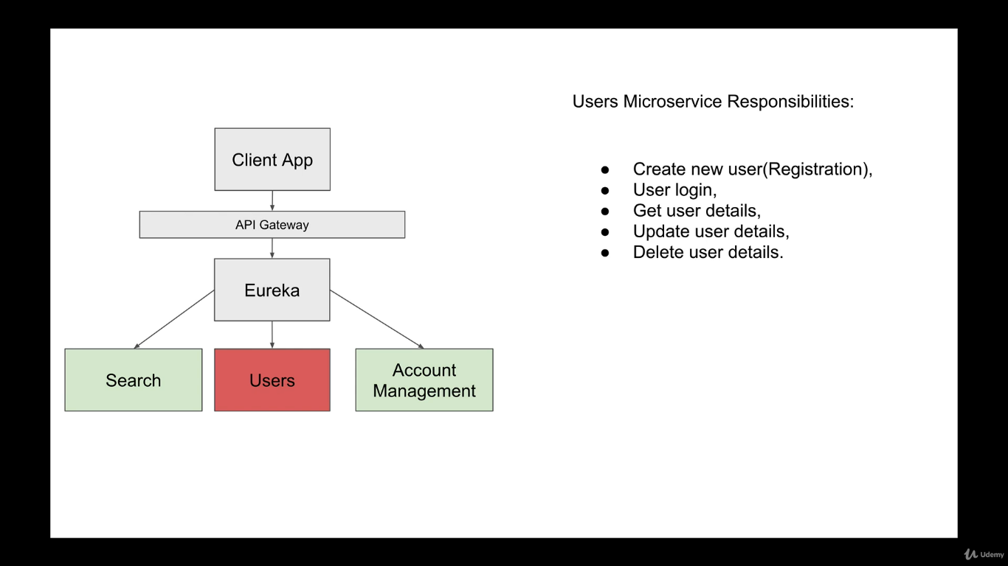

Add the eureka client dependency

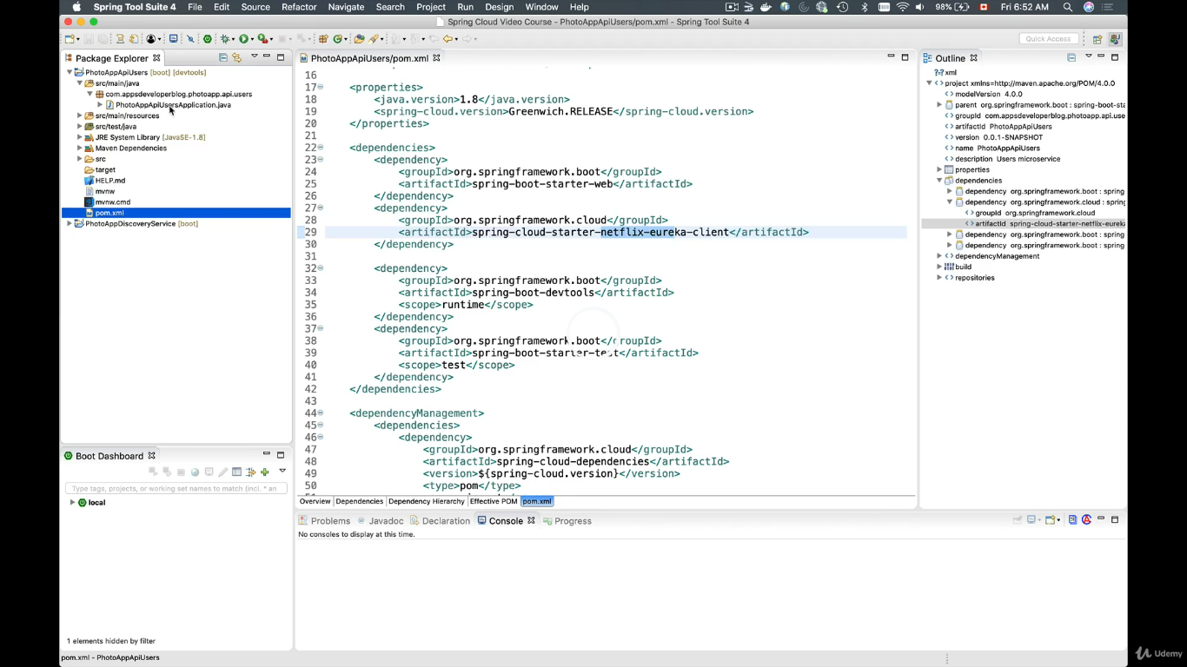

Add @enableDiscoveryClient

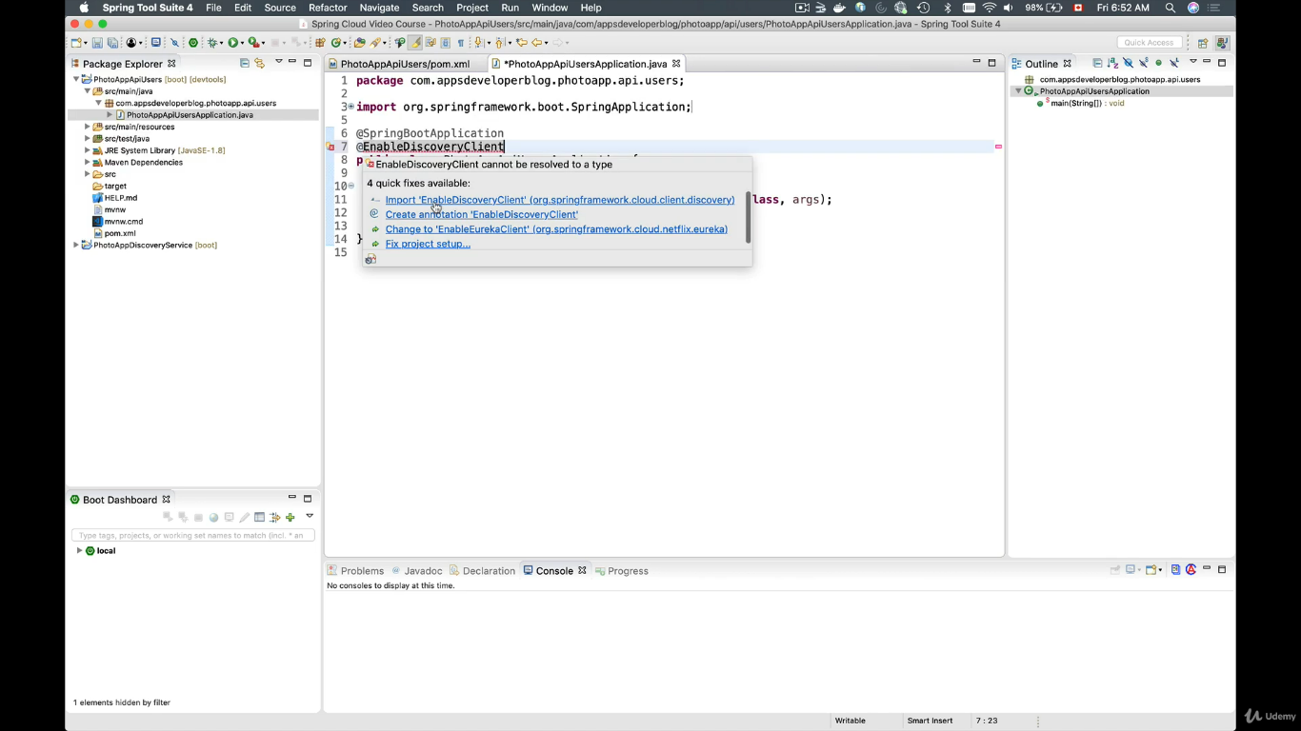

Add the following properties

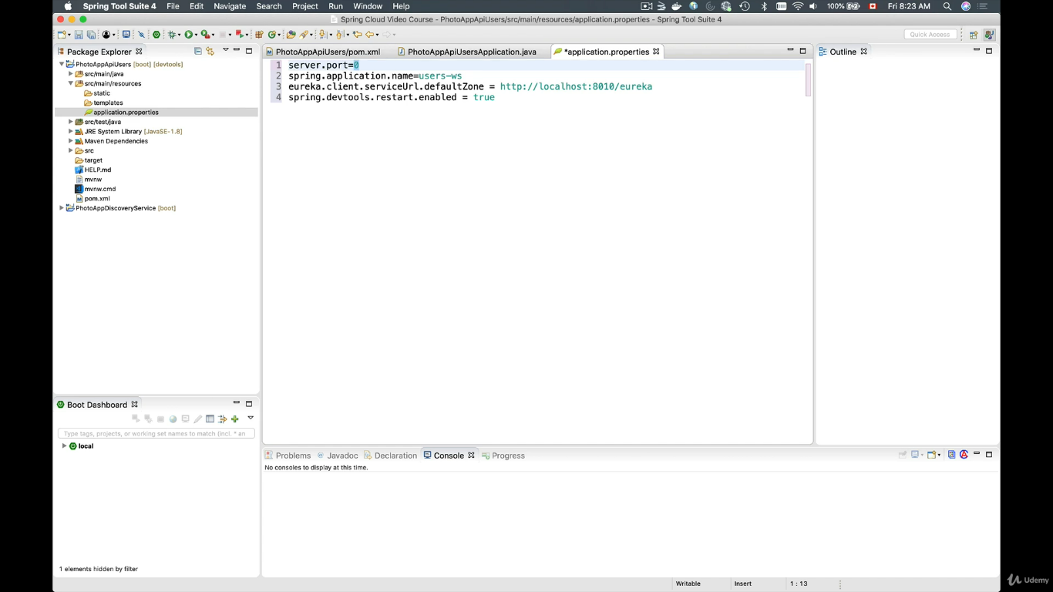

Server.port = 0.

This will let the eureka server to automatically assign the port number when multiple instances are created. And this manages the port number from being conflicted.

eureka.client.serviceUrl.defaultZone = <http://localhost:8010/eureka>

this is the url via which eureka client will communicate to eureka server.

**At the time of running the microservices, first we need to start the eureka server then we have to start the eureka client**

You can see the microservice is registered below.

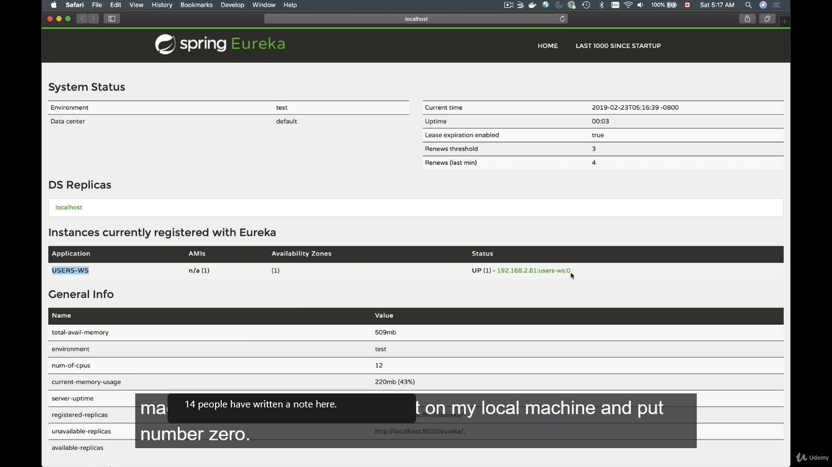

You can see the port number 0 is assigned as of now but when you click it will open with a different port number.

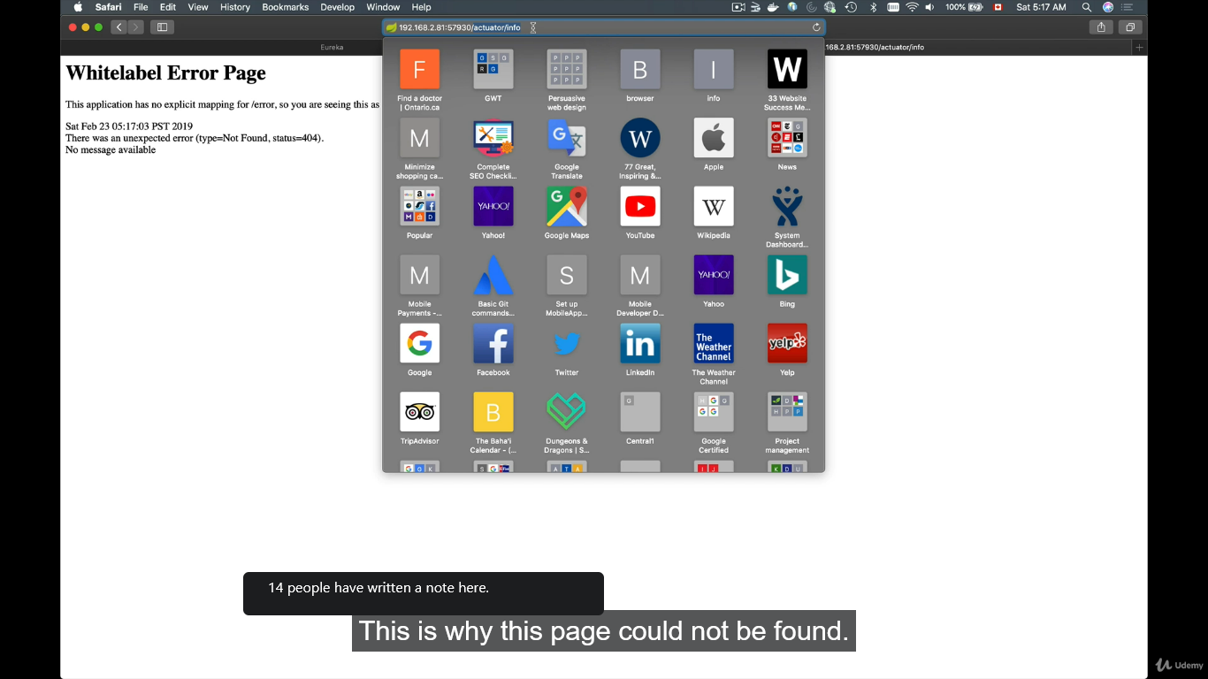

The port is automatically assigned.

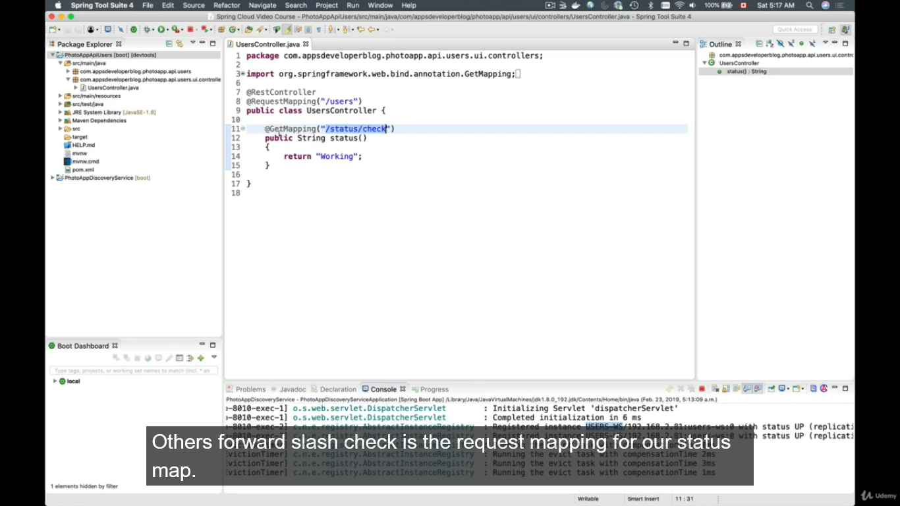

Navigate the to the url shown above

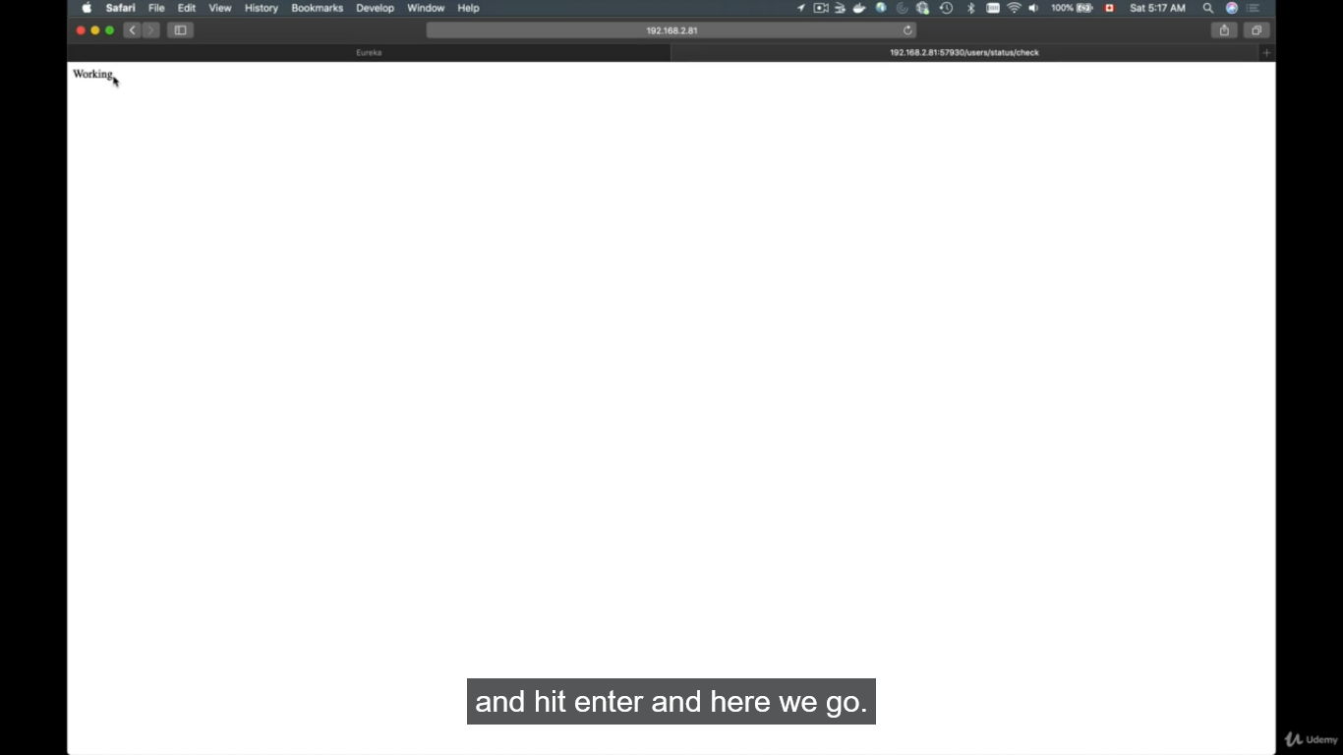

Spring cloud API Gateway.

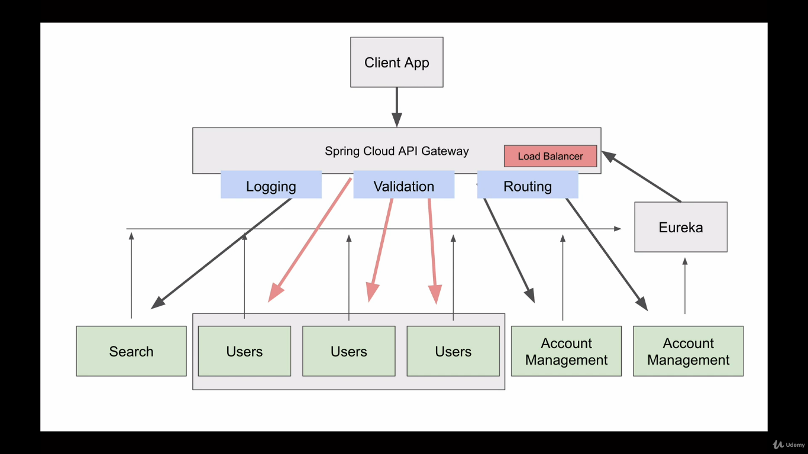

micorservices startup and register with eureka server.

when we scale up each microservice it will register with eureka server with unique address. Now the request from the client app must be balanced with available microservices. And to route the request to available microservices we have to use spring cloud api gateway.

Spring cloud gateway will distribute request equally to running microservices.

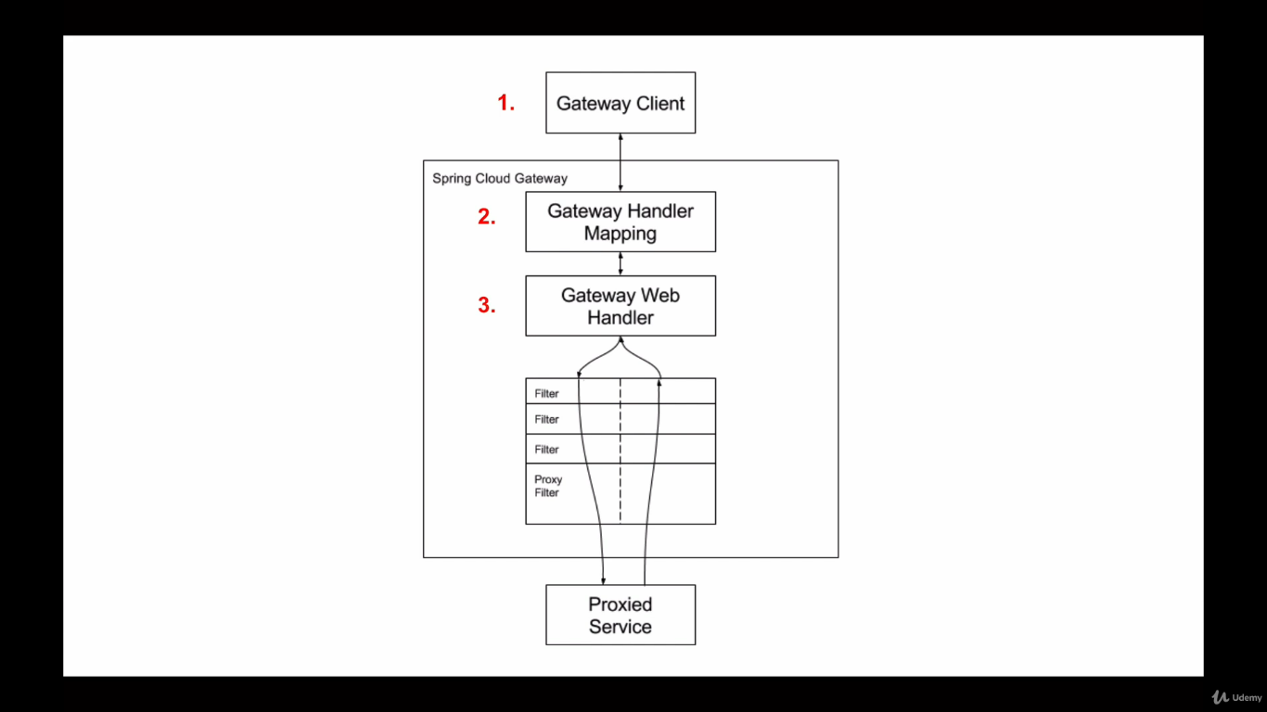

1. **Gateway client** is noting but the client application sends the http request.
2. **Gateway handler mapping** checks the requested url and handed over to **Gateway Web Handler**
3. **Gateway Web Handler** pass through the request through all the filters before and after reaching the requested url.

**Creating API Gateway Project:**

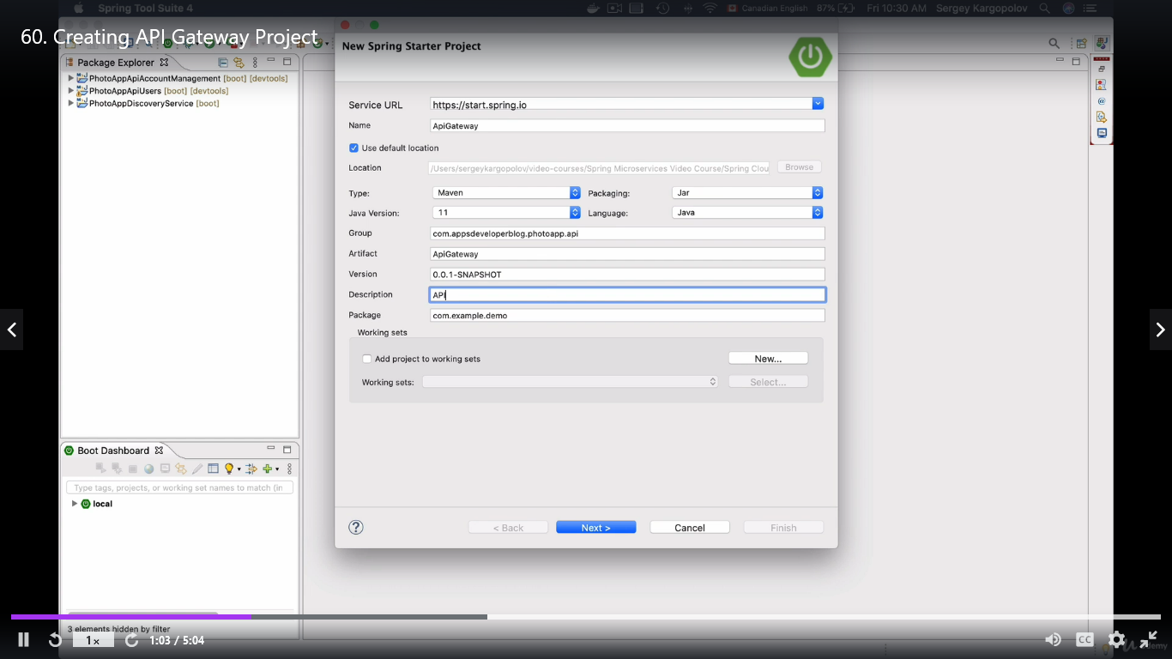

Add the dependencies, 1) Spring cloud gateway 2) WebFlux 3) Eureka Discovery Client

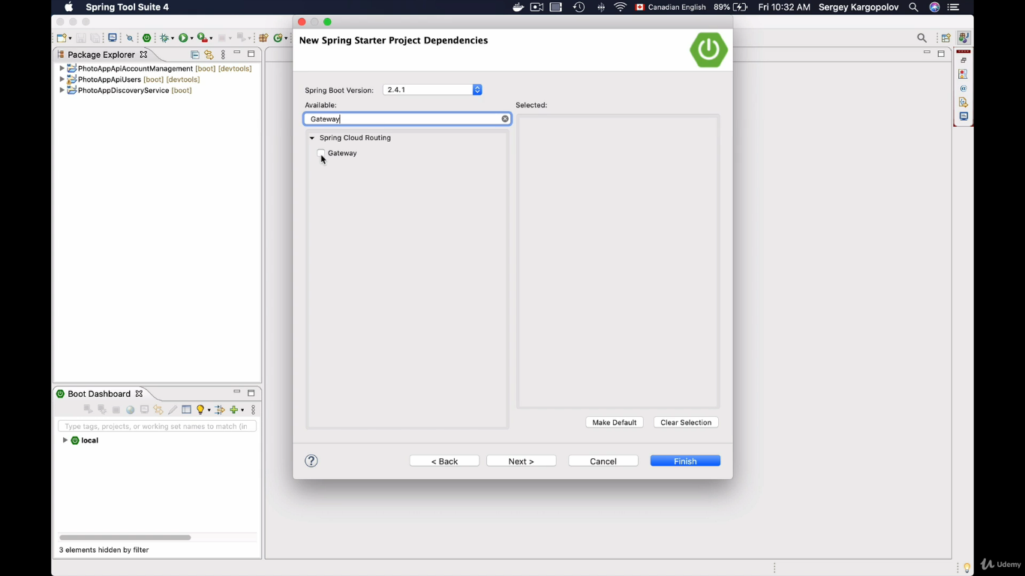

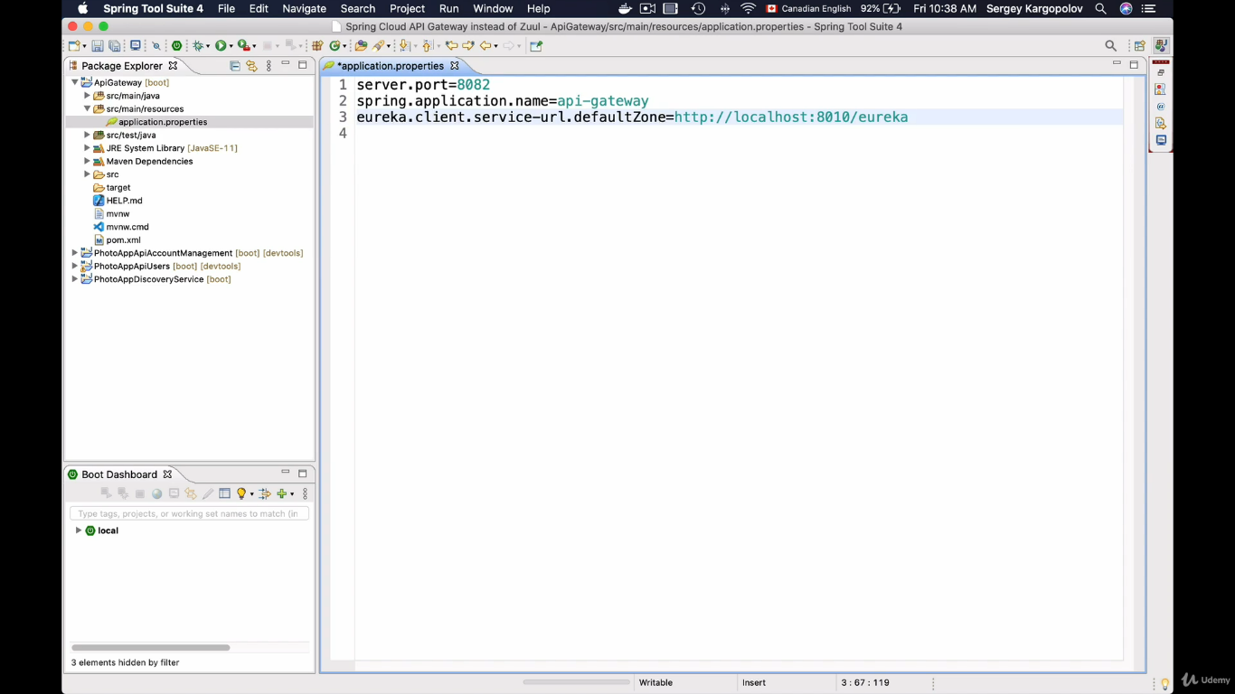

Once we have our API gateway project created, we have to enable the auto locator, this will locate the request automatically. To enable auto locator see the below image.

spring.cloud.gateway.discovery.locator.enabled = true

now start the application 1) eureka server 2) api gateway 3) user service

send the request to 8082 which is api gateway.

Localhost:8082/USER-WS/users/check/status

Now the request will work but if you change the url into lowercase it will not work

Localhost:8082/users-ws/users/check/status.

To support this lower case locator add the following property.

spring.cloud.gateway.discovery.locator.lower-case-service-id = true

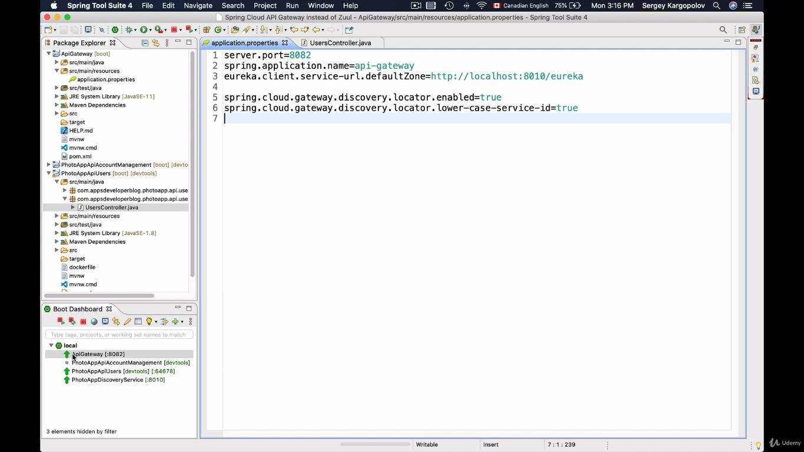

Now it will work with lower case.

**Manually configuring API Gateway Routes:**

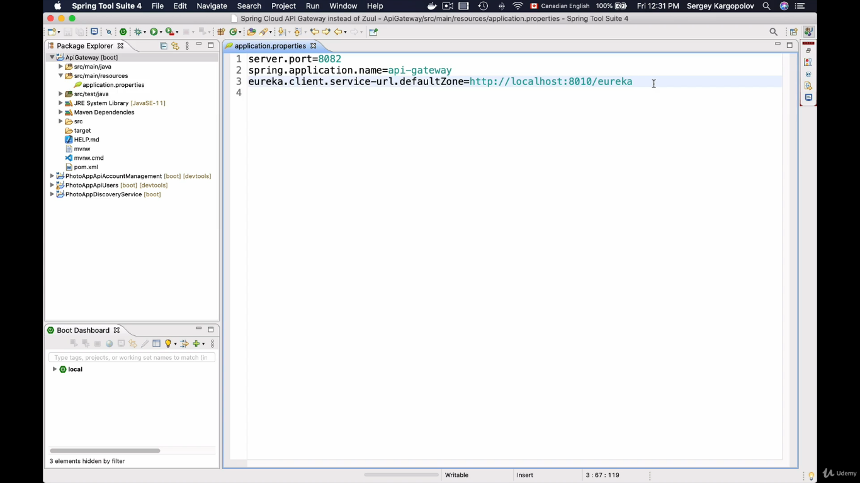

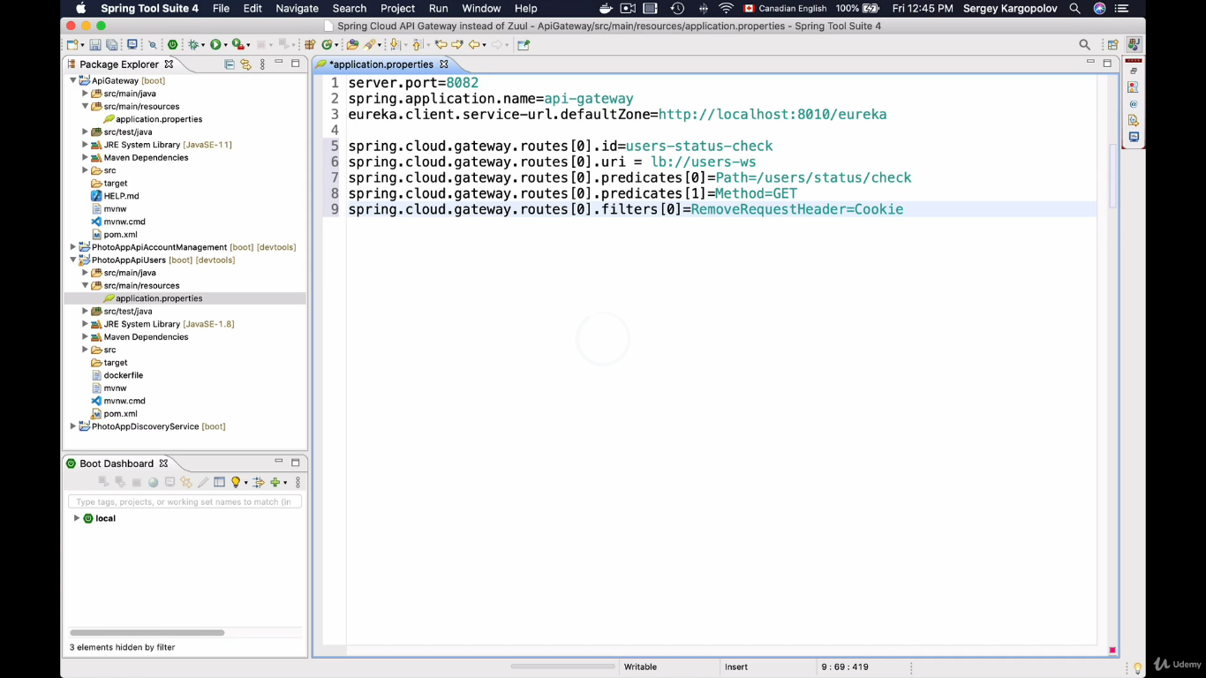

we can create multiple route with an array of object.

property to configure it manually is,

spring.cloud.gateway.routes[0].id = users-status-check

spring.cloud.gateway.routes[0].uri = http://localhost:8081 or lb://users-ws

spring.cloud.gateway.routes[0].predicate[0]=path=/users/status/check

spring.cloud.gateway.routes[0].predicate[1]=Method=GET, Post

spring.cloud.gateway.routes[0].filter[0]=RemoveRequestHeader=Cookie

1. id: is to create unique id for this route

2. uri: provide uri, it can be name under which micorservice is registered in eureka discovery service or IP address and host name.

Since we are fetching the port number automatically assigned we will give the value in the below manner to fetch the details from eureka server.

lb stands for load balancer.

3. Predicate: is to check the condition, if it matches then process the request. Since predicate can be many so we mention it as an array.

now with the below settings path must be [/users/status/check] and request method must be Get,Post

4. This filter is inbuilt filter, it will remove the cookie from the request header as we don't need cookie but all we need is JWT token.

since this is an inbuilt filter we don't have to write custom code but in upcoming lessons we will see how to write a custom filter. **Run the application and check**

**Rewrite path:** is nothing but user will enter one part but api gateway will route to the internal path.

spring.cloud.gateway.routes[0].id = users-status-check

spring.cloud.gateway.routes[0].uri = http://localhost:8081 or lb://users-ws

spring.cloud.gateway.routes[0].predicate[0]=path=users-ws/users/status/check  **(user entered path)**

spring.cloud.gateway.routes[0].predicate[1]=Method=GET, Post

spring.cloud.gateway.routes[0].filter[0]=RemoveRequestHeader=Cookie

spring.cloud.gateway.routes[0].filter[1]=RewritePath =users-ws/users/status/check, users/status/check(Internal path)

**Run the application and check**

**Load Balancer:**

Start multiple microservices multiple times.

since our port is assigned as zero server.port = 0.

no matter how many times we start the microservice instance, it will show as only one microservice in eureka dashboard. But in the background all those microservices started will be running.

To see all the microservice running on eureka dashboard add the following property.

eureka.instance.instance-id = ${spring.application.name}:${spring.application.instance_id:${random.value}}

instance id will be generated randomly. **Run the program multiple times.**

If we don't want the instance id to be generated randomly but want to give the customized id from command prompt while running the program we have to do the following changes.

1. open cmd

2. copy the project path from IDE.

3. navigate to the copied path in cmd.

4. execute the maven command to run the app

mvn spring-boot:run Dspring-boot.run.arguments=--spring.application.instance_id = saddam

5. check the eureka dashboard a new application with name saddam would be registerd.

like wise we can assign the port number from command line instead of letting it assigned automatically.

server.port = ${PORT:0}

In the above case port number will be automatically assigned if we do not give the port number from command line

1. open cmd

2. copy the project path from IDE.

3. navigate to the copied path in cmd.

4. execute the maven command to run the app

mvn spring-boot:run Dspring-boot.run.arguments=--spring.application.instance_id = saddam2, --server.port=9999

5. check the eureka dashboard a new application with name saddam2 would be registered with custom port number.

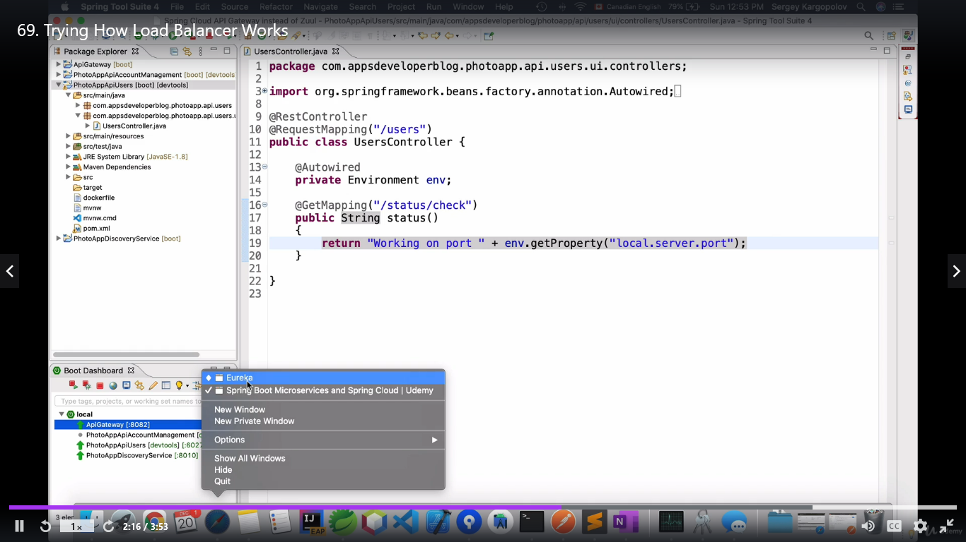

Run the app and check the port number to check how the load balancer is distributing the request among the running microservice instances.